ANSWERS

1. pwd- it shows the present working directory
Whoami- shows the username
Hostname- shows the hostname

2.command:\
Cd /home
Mkdir /home/student
Mkdir /home/student/project
Cd /home/student/project
Touch file1.txt file2.txt file3.txt

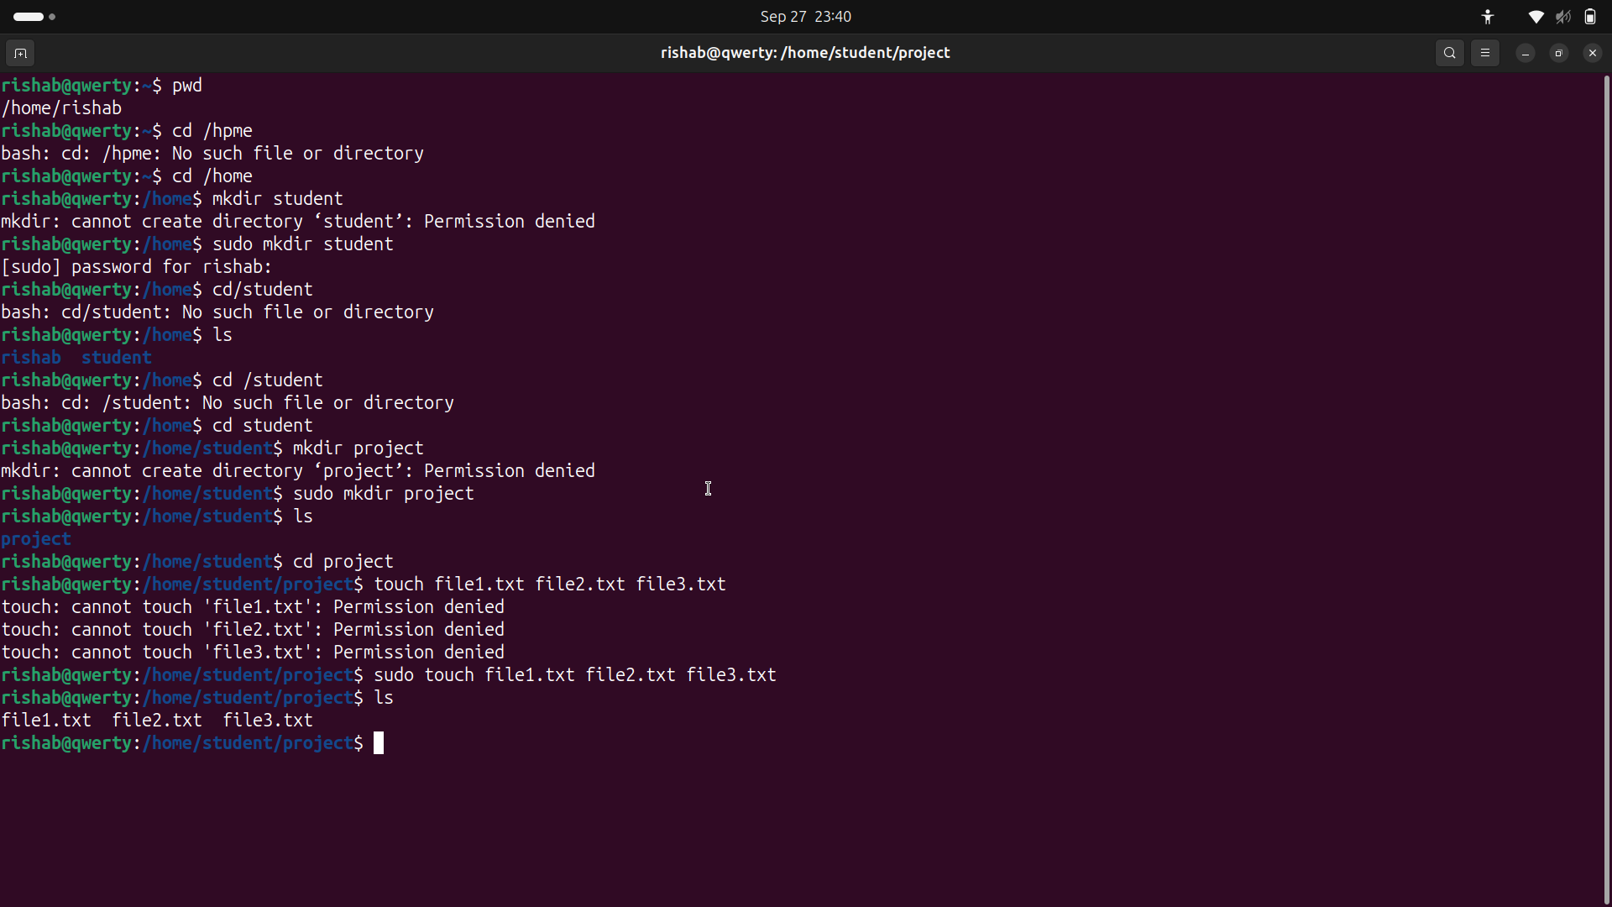

3.An absolute path specifies the full path to a file or directory, starting from the root directory
It always begins with /.It doesn’t depend on where you currently are in the file system.

Example: Absolute path to file1.txt inside /home/student/project:

/home/student/project/file1.txt

A relative path specifies the location of a file or directory in relation to your current working directory (cwd).It does not start with /

Example: Assume you are inside /home/student:
Relative path to file1.txt in project folder:
project/file1.txt

4.command is ‘history’ and ‘history 10’ for only the last 10 commands.
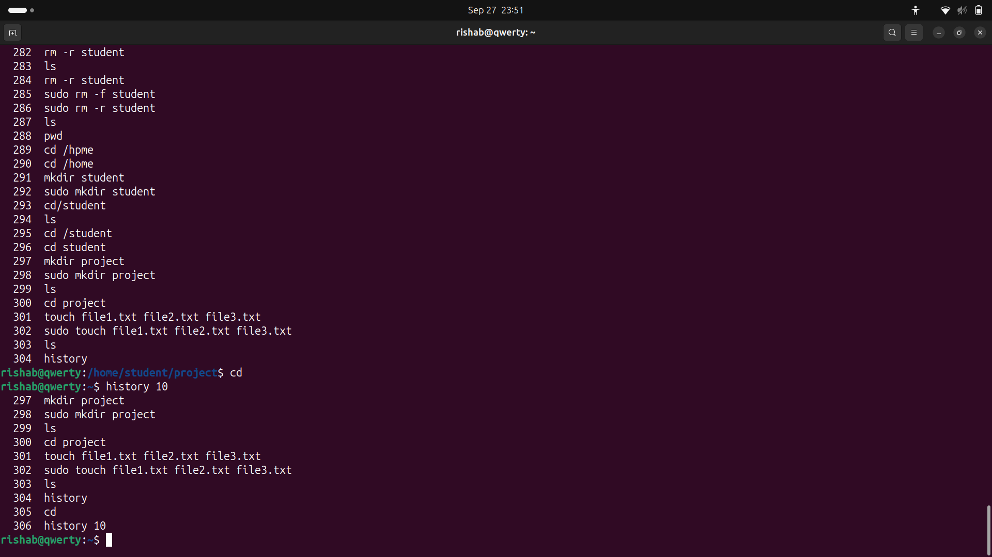

5.’locate’ is faster than ‘find’ because find scans the whole disk in realtime. But locate acts like a search engine. It just scans a prebuilt database.’locate’ may always be faster but it's not always accurate but on the other hand ‘find’ is slower but it is always accurate.

6.The chmod command is used to change the file permissions in Unix-like operating systems.It allows you to set who can read, write, or execute a file.

chmod [options] mode[,mode] file1 [file2 ...]

7. It means that only the owner can read and write the file and others can only read the file.

8. The chown command is used to change the ownership of files and directories in Unix-like operating systems.It allows you to set which user and group own a file.
chown rishab:developers file.txt (here ownership is being passed to user ‘rishab’ and group ‘developers’.)
The chgrp command is used to change the group ownership of files and directories in Unix-like operating systems. It allows you to set which group owns a file.
chgrp developers file.txt

9. Suppose we take the file as ‘file1.txt’ which is in ‘/home/student/project’. The command is
Chmod 644 file1.txt
Or
Chmod u=rw,g=r,o=r file1.txt

But first we might need to change the ownership of the file.the command is
sudo Chown rishab:rishab file1.txt

10. By using the ‘man’ command.

